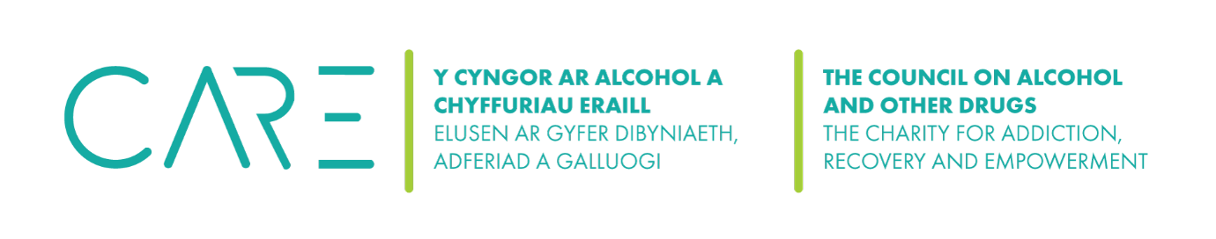
The Council on Alcohol and Other Drugs (CAOD) Social media consent form
Please complete this form if you are happy to give your permission to be filmed, photographed, or recorded by the Council on Alcohol and Other Drugs (CAOD). Please do not feel under any pressure to agree to take part and remember, you can stop the filming, photography or recording at any time and for any reason.
I hereby grant permission to the Council on Alcohol and Other Drugs (CAOD) to use my photograph, film, or audio recording in its media relations, including printed form, social media, and its website or in other official printed publications without further consideration.
I acknowledge the Council on Alcohol and Other Drugs’ (CAOD) right to crop or edit the photograph, film, audio recording or interview at its discretion. I also acknowledge that the Council on Alcohol and Other Drugs (CAOD) may choose not to use my photo or recording at this time. However, please note that the Council on Alcohol and Other Drugs (CAOD) will control the copyright to your picture, film, audio recording, or interview and therefore it could be reused in the future without any further permission being sought from you.
I also understand that if my image or recording is posted on the Council on Alcohol and Other Drugs’ (CAOD) website, the image can be downloaded by any computer user. Therefore, I agree to indemnify and hold harmless from any claims the following:
- Board of Trustees
- Any employees and volunteers of the Council on Alcohol and Other Drugs (CAOD)

The Council on Alcohol and Other Drugs (CAOD) reserves the right to discontinue use of photos without notice.
Name: ______________________________________________________________________________
Address: ___________________________________________________________________________
____________________________________________________________________________________
Contact no: ____________________________ Email: _______________________________________
Signature: __________________________________ Date: ________________________________
____________________________________________________________________________________

The Council on Alcohol and Other Drugs’ (CAOD contact details:
Website:
Email:
Phone: 07796464045

